Shopify → Faire Fulfillment Sync
N8N Automation Report

Trigger | Shopify — Fulfillment Created (Webhook)
Platform | N8N
Integrations | Shopify, Faire API, Shopify GraphQL, OpenAI GPT-4o-mini
AI Model | GPT-4o-mini via OpenAI
Output | Shipment created in Faire with tracking & shipping cost

Overview
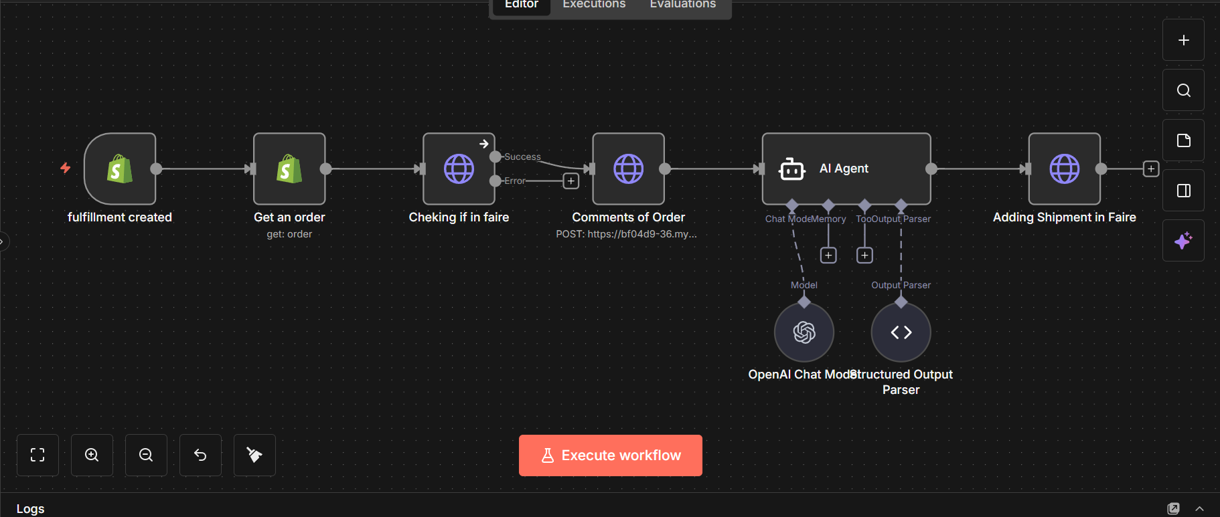
This workflow automates the fulfillment sync between Shopify and Faire.com. When a seller purchases a shipping label and fulfills an order in Shopify, the workflow automatically detects if the underlying order originated from Faire, extracts the shipping label cost from the order's event history using an AI agent, and registers the shipment on Faire with the correct carrier, tracking code, and shipping cost, eliminating the need for any manual double-entry between the two platforms.

How It Works — Step by Step
- Step 1: Fulfillment Created trigger fires in Shopify when a seller ships an order.
- Step 2: The workflow fetches full order details from Shopify using the order ID.
- Step 3: It calls the Faire API to check whether this order exists on Faire (matched by order name/number). If not found, the workflow stops.
- Step 4: Shopify's GraphQL API is queried to retrieve all events/comments attached to the order, which include shipping label purchase messages.
- Step 5: An AI Agent (GPT-4o-mini) reads all order events and extracts only the shipping label price, ignoring unrelated messages, and returns a structured JSON output.
- Step 6: The workflow posts the shipment to Faire with the carrier name, tracking number, and the extracted shipping label cost (in cents).

Challenges & How the Workflow Addresses Them
- Shipping cost not available in fulfillment data: Faire requires the shipping cost (maker_cost) when registering a shipment, but Shopify's standard fulfillment webhook does not expose this value directly.
- → The workflow queries Shopify's order event timeline via GraphQL and uses an AI agent to identify and extract only the shipping label purchase message from amongst all event types.
- Noisy event data: Order events contain many unrelated messages (product notes, tracking confirmations, insurance, etc.), making it unreliable to extract the price with simple string matching.
- → A dedicated AI Agent with a strict system prompt and Structured Output Parser (JSON schema enforced) is used to reliably isolate the shipping label price and return null if none is found.
- Faire-only filtering: Not every Shopify fulfillment corresponds to a Faire order, and sending a shipment to Faire for a non-Faire order would cause errors.
- → The Faire API lookup step uses the error output branch — if the order is not found on Faire, execution halts via the onError: continueErrorOutput setting, preventing any further processing.
- Currency unit conversion: Faire's API expects the shipping cost in minor currency units (cents), but the AI agent returns a decimal dollar value.
- → The shipment payload multiplies the extracted price by 100 and rounds it to ensure a valid integer cent value is submitted.

Tools & Integrations
Tool / Service | Role in Workflow
Shopify Trigger | Detects fulfillment creation events in real time
Shopify Node (REST) | Retrieves full order details by order ID
Faire REST API | Verifies order origin and registers shipment
Shopify GraphQL API | Fetches order event timeline / comments
OpenAI GPT-4o-mini | Extracts shipping label price from unstructured event text
Structured Output Parser | Enforces strict JSON schema on AI response

